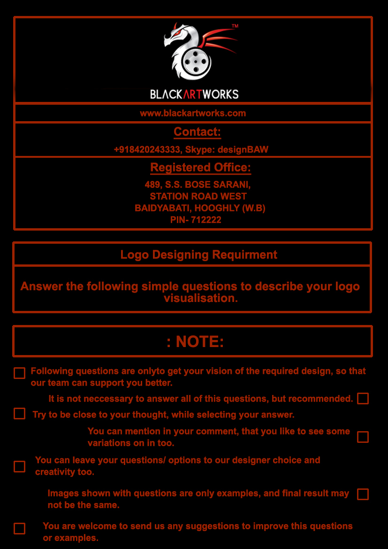

2- What is your business domain? Company Business:

3- Do you have a tag line or a slogan?
4- Do you want your logo to represent something or some idea?

1- What exact words (name of your company) should appear in your logo:

*** If you need Help to Fill Up this form , then contact on this Number ( +91 9903167282 )
5- Need some specific symbols? Images? Or Object to be included in your logo?

8- Do you like corporate look and feel?

7- Preferences about fonts?

6- Preferences about colors?

*** If you need Help to Fill Up this form , then contact on this Number ( +91 8420243333 )

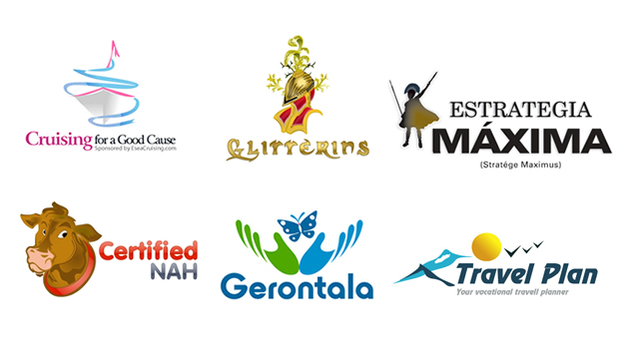
9- Need Illustrative / cartoon style logo? like some examples below.

*** If you need Help to Fill Up this form , then contact on this Number ( +91 8420243333 )
10- Which type of logo do you wish to see from following?

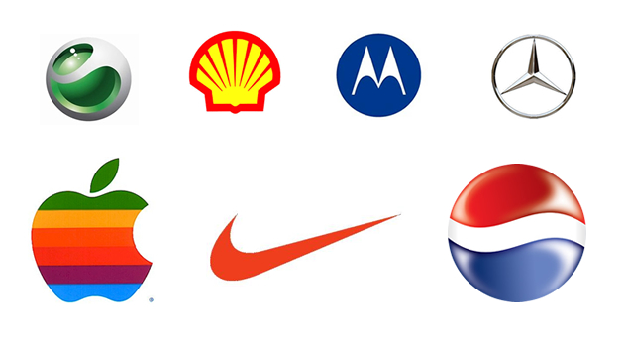

Iconic/Symbolic

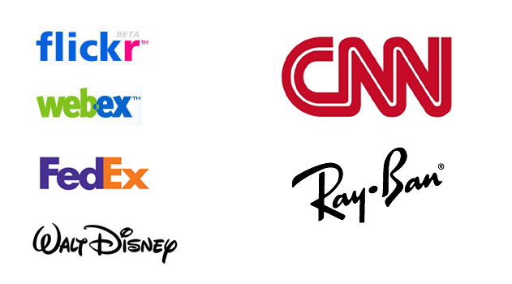
Wordmarks (made of word)

*** If you need Help to Fill Up this form , then contact on this Number ( +91 8420243333 )

Any Comments or Instructions for Type of Logo:
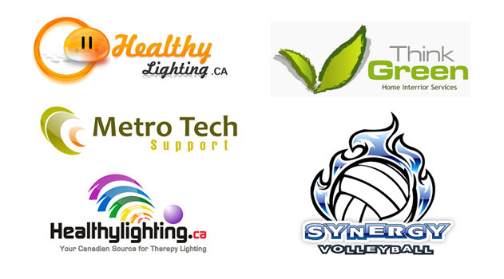
Combination Marks (combination of words and symbol)

*** If you need Help to Fill Up this form , then contact on this Number ( +91 8420243333 )

Email:

Phone Number:
Full Name:

12- Applicant Information:

11- Please reference some URL or Logo you are inspired with. (if any)

*** If you need Help to Fill Up this form , then contact on this Number ( +91 8420243333 )

